Contributor: Marta Dansie

**Hyppolite, Hector**

Born: c.1894 (uncertain) – Saint Marc, Haiti; Died: 1948 – Port-au-Prince, Haiti

Haitian painter Hector Hyppolite is best known for his inventive depictions of Haitian religious practices called voodoo (*vodou* in Haitian Creole), and his portraits of spirits or *loa*. Hyppolite was one of Haiti’s most celebrated artists from the mid-twentieth century onwards, a period that has been termed a renaissance for Haitian art. Hyppolite joined the Centre d’Art, a studio and exhibition space for artists in Port-au-Prince, Haiti in 1945. In the three years before his sudden death in 1948 his work was prodigious, consisting of hundreds of paintings, exhibited in Haiti and abroad during his lifetime. Soon after Hyppolite delivered his first paintings to the Centre d’Art, André Bretonbought several, displayed them in Paris, and claimed Haitian painting for Surrealism. Hyppolite’s prominence during the early days of the Centre d’Art, founded in 1944, made him a leading figure in Haiti’s so-called naïve art movement. Hector Hyppolite’s eccentric persona fueled his popularity with foreign audiences. Collectors and critics were as fascinated by Hyppolite’s polemic lifestyle as much as by his paintings. Hyppolite clearly understood that myth-making is part of the modern artist’s toolkit. His untimely death in 1948, as his reputation as an artist was growing, left many questions about his life unanswered.

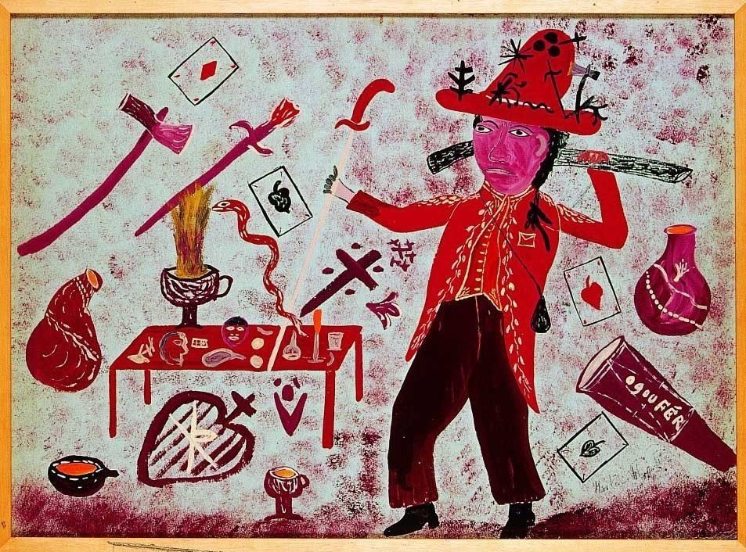

Hector Hyppolite*, Ogou Fer,* 1946, oil on board, 20 x 27 inches, former collection of André Breton, collection of Larry Kent.

[Image available online:

<http://www.andrebreton.fr/fr/item/?GCOI=56600100387450&fa=author&Person_ID=540>

The current owner, Larry Kent’s email: larryknt@yahoo.com

In the twentieth century little formal art training was available in Haiti, and few could afford to travel to receive academic instruction. When the Centre d’Art began to offer free art supplies and to create a market for the work of untrained artists, a vigorous popular art movement arose. Haitian novelist Philippe Thoby-Marcelin (1904-1975), the editor for the Centre d’Art’s journal *Studio No. 3,* tracked Hyppolite from a café whose door he had decorated with birds and flowers and found the artist using chicken feathers and left-over paints to decorate furniture and make murals. While this story confirms that Hyppolite was a working artist before he joined the Centre d’Art, his artwork had never before been recognised. Prompted to begin painting in earnest, Hyppolite dedicated himself to the task and made many paintings with board and oil paints provided by the Centre.

Hyppolite presented himself as a *vodou* priest or *houngan*, often painted religious subject matter, and said that the spritis or *loa* inspired him to paint. He illustrated a book by Milo Rigaud about ceremonial drawings, known as *vèvè*, made on the ground with powder such as flour. Hyppolite was understood, at least by his predominantly foreign audience, to be a representative of the *vodou* religion, which had been aggressively persecuted by the Haitian government in coordination with the Catholic Church for hundreds of years. A particularly devastating iconoclastic campaign, which resulted in the destruction of thousands of treasures of popular art associated with *vodou* practices, including pre-Columbian objects, ended only in 1942. Thus, prior to opening of the Centre d’Art in 1944 and the contemporaneous rise of the Ethnographic movement which promoted pride in the African heritage of local culture and *vodou*, artwork with *vodou* themes such as Hyppolite’s would have been suppressed in Haiti, making his production an invaluable one.

**Further reading:**

Barnitz, J. (2001) "Surrealism, Wartime, and New World Imagery, 1928-1964." *In Twentieth-Century Art of Latin America*, 103-126. Austin: University of Texas Press.

Breton, A. and M. Duchamp, eds. (1947) *Le surréalisme en 1947: Exposition international du surréalisme*. Exhibition catalogue. Paris: Maeght.

Le Clézio, J. M. G., L. F. Manigat, M. P. Lerebours, C. A. Célius, G. Alexis, L. G. Benson et al. (2011) *Hector Hyppolite*. Exhibition catalogue. Paris: Editions de Capri et Comité Hector Hyppolite.

Racine, F., ed. (2009). *Mystical Imagination: The Art of Haitian Master Hector Hyppolite*. Exhibition catalogue. Washington, D.C. : Art Museum of the Americas, Organization of American States.

Peters, DeWitt. (2004) "Haitian Art... How it Started." In *Readings in Latin American Modern Art,* edited by Patrick Frank, 67-72. New Haven: Yale University Press.

Marcelin, M. (1949) *Mythologie vodou (rite arada),* Port-au-Prince: Éditions haïtiennes.

Rodman, S. (1948) *Renaissance in Haiti: Popular Painters in the Black Republic*. New York: Pellegrini & Cudahy.

Rodman, S. (1988) *Where Art is Joy: Haitian Art: The First Forty Years*. New York: Ruggles de Latour.

Rodman, S. (2004) "A Visit with Hector Hyppolite." In *Readings in Latin American Modern Art*, edited by Patrick Frank, 73-75. New Haven: Yale University.

**List of Works:**

Hector Hyppolite*, Ogou Fer,* 1946, oil on board, 20 x 27 inches, former collection of André Breton, collection of Larry Kent.  
  
Hector Hyppolite*, Damballah La Flambeau,* c.1946-48, oil on board, 30 x 24 inches, collection of Ute Stebich.

Hector Hyppolite*, L’Union Fait la Force*, c.1946-48, oil on cardboard mounted on wood, 29 15/16 x 26 5/16 in., Hirshhorn Museum and Sculpture Garden, Smithsonian.

Hector Hyppolite*, Nap Pile (Crushing Grain),* c.1946-48, oil on board, 16 x 20 inches, Waterloo Center for the Arts.

Hector Hyppolite*, Resting Woman,* c.1947, oil on board, 24 x 30 inches, Musée d’Art Haitien du College St. Pierre.

Possible online video links:

For context, this black and white film about the Centre d’Art in Port-au-Prince in 1950, in French, mentions Hector Hyppolite showing an image of his artwork, was produced with the United States Information Service, and is available on YouTube (I understand that works of the U.S. Government are automatically copyright-free):

Cypher, S. (1950). *L'Art en Haïti*.

<https://www.youtube.com/watch?v=EddjisayOtQ>

Video presenting thematic analysis of a recent exhibition of Haitian art, including a painting Hector Hyppolite:  
An introduction to Kafou: Haiti, Art and Vodou by Alex Farquharson Director of Nottingham Contemporary and Co-Curator of the show. Particularly focusing on how zombies are represented in Haitian art and begins with a painting by Hector Hyppolite.  
[http://www.nottinghamcontemporary.org...](http://www.nottinghamcontemporary.org/art/kafou-haiti-art-and-vodou%22%20%5Ct%20%22_blank%22%20%5Co%20%22http://www.nottinghamcontemporary.org/art/kafou-haiti-art-and-vodou)  
Nottingham Contemporary show Kafou: Haiti, Art and Vodou, 20 October 2012 - 06 January 2013